**Hoisting and Scope**

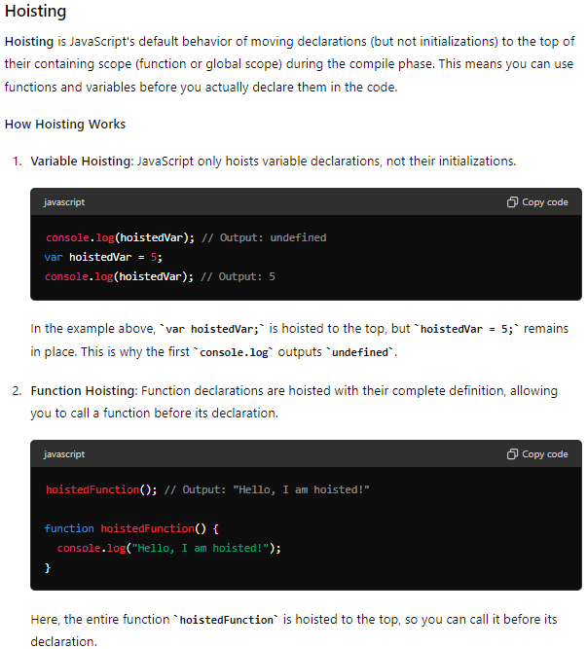

**Scope**

**Scope** determines the visibility and lifetime of variables and functions within the code. JavaScript has two main types of scope: **Global Scope** and **Local Scope**.

**Global Scope**

Variables declared outside any function or block are in the global scope. They can be accessed from anywhere in the code.

#### Local Scope

Variables declared within a function are in the local scope (or function scope). They are accessible only within that function.

#### Block Scope

ES6 introduced block scope with let and const. Variables declared with let or const inside a block {} are scoped to that block only.